**Rossmoyne Senior High School**



**Semester 1 Examination 2012**

**Question/Answer Booklet**

(This paper is not to be released to take home before 25/6/2012)

**MATHEMATICS 3A**

**Section One:**

**Calculator-free**

Name of Student: _____________________Marking key_______________________

**Time allowed for this section**

Reading time before commencing work: 5 minutes

Working time for this section: 50 minutes

**Materials required/recommended for this section**

***To be provided by the supervisor***

This Question/Answer Booklet

Formula Sheet

***To be provided by the student***

Standard items: pens, pencils, pencil sharpener, eraser, correction fluid/tape, ruler,

highlighters

Special items: nil

**Important note to students**

No other items may be used in this section of the examination. It is **your** responsibility to ensure

that you do not have any unauthorised notes or other items in the examination room. If you have any unauthorised material with you, hand it to the supervisor **before** reading any further.

**Structure of this paper**

|  |  |  |  |  |  |
| --- | --- | --- | --- | --- | --- |
| Section | Number of questions available | Number of questions to be answered | Working time  (minutes) | Marks available | Percentage of exam |
| Section One  Calculator-free | 6 | 6 | 50 | 50 |  |
| Section Two  Calculator-assumed | 13 | 13 | 100 | 100 |  |

|  |  |  |
| --- | --- | --- |
| Total | 150 | 100 |

**Instructions to students**

1 Write your answers in the spaces provided in this Question/Answer Booklet. Spare pages are included at the end of this booklet. They can be used for planning your responses and/or as additional space if required to continue an answer. If you need to use the space to continue an answer, indicate in the original answer space where the answer is continued. i.e. give the page number. Fill in the number of the question(s) that you are continuing to answer at the top of the page.

2 **Show all your working clearly**. Your working should be in sufficient detail to allow your answers to be checked readily and for marks to be awarded for reasoning. Incorrect answers given without supporting reasoning cannot be allocated any marks. For any question or part question worth more than two marks, valid working or justification is required to receive full marks. If you repeat an answer to any question, ensure that you cancel the answer you do not wish to have marked.

3 It is recommended that you **do not use pencil**, except in diagrams.

**Section One: Calculator-free (50 marks)**

This section has **six (6)** questions. Answer all questions. Write your answers in the spaces provided.

Working time: 50 minutes

_________________________________________________________________________________

**Question 1 (5 marks)**

The marks in Mr Green’s Chemistry test are normally distributed. The mean is 100 and the standard deviation is 10.

(i) Jon’s mark is 115. What is his Z-score? (1)

|  |
| --- |
| **Solution** |
|  |
| **Specific behaviours** |
| ✓ or X |

(ii) Christopher has a Z-score of -2. What mark did he achieve in the test? (1)

|  |
| --- |
| **Solution** |
| X = 80 |
| **Specific behaviours** |
| ✓ or X |

(iii) What percentage of marks lie between 80 and 110? (3)

You may assume the following:

68% of marks have Z-scores between -1 and 1

95% of marks have Z-scores between -2 and 2

99.7% of marks have Z-scores between -3 and 3

|  |
| --- |
| **Solution** |
| 100  110  80  80 is 2 standard deviations to the left of the mean  110 is 1 standard deviation to the right of the mean  Percentage of scores between 80 and 110 = |
| **Specific behaviours** |
| ✓ identifying 110 has a z-score of 1  ✓✓ calculates the region between 80 and 110 as 0.815 |

**Question 2 (8 marks)**

(a) Jonathon used the ‘capture-recapture’ technique to estimate the number of yabbies living in a dam.

* He caught, tagged and released 20 yabbies.

* Later he caught 36 yabbies at random from the same dam.

* He found that 8 of these 36 yabbies had been tagged.

Estimate the total number of yabbies living in this dam. (3)

|  |
| --- |
| **Solution** |
| Let population be x      Total number of yabbies is 90 |
| **Specific behaviours** |
| ✓  ✓✓ rearrange and simplify x to 90 |

(b) Which of the following frequency histograms shows data that could be normally distributed? (1) (A) (B) 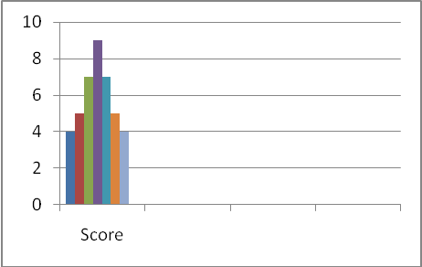



(C) (D) 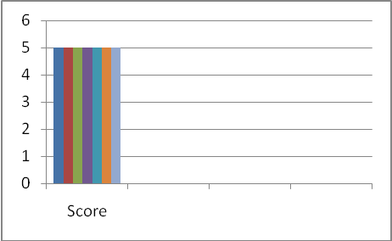



|  |
| --- |
| **Solution** |
| Graph B |
| **Specific behaviours** |
| ✓ or X |

**Question 2 (continued)**

(c) Radar checks were carried out on the speed driven by drivers on two days, on a stretch of Spencer Road. The results are tabled below.

|  |  |  |  |
| --- | --- | --- | --- |
| Days | Mean | Standard deviation | Number of drivers |
| Wednesday | 60 | 10 | 100 |
| Thursday | 70 | 5 | 100 |

On which day would you expect there to be more drivers exceeding 85km/h? Explain your answer. (2)

|  |
| --- |
| **Solution** |
| Wednesday because 85 = 60 +2.5 while Thursday 85 = 70 + 3 |
| **Specific behaviours** |
| ✓ Wed  ✓ valid reason |

(d) The height of students in Mrs Smith’s class range from 150cm to 175cm. Their heights were measured one day and it was found that the mean height was 160cm. Two students were absent on the day when the measurement was taken. When the heights of the absent students were included in the data, the mean height did not change. What are two possible heights of the two absent students? (2)

|  |
| --- |
| **Solution** |
| Mean of the two absent students is 160  Possible heights are 150 cm and 170 cm, 155 cm and 165 cm, 151 and 169 cm  Any combination such that the sum is 320 cm and range from 150 to 170 cm |
| **Specific behaviours** |
| ✓✓ two correct answers |

**Question 3 (7 marks)**

LMN is drawn with LN = 3k units, MN = (4k+1) units and LM = (3k-1) units with k>0.



(i) Which side of LMN is the longest side? Justify your answer **algebraically**. (3)

|  |
| --- |
| **Solution** |
| And    MN is the longest side |
| **Specific behaviours** |
| ✓✓ algebraic reasoning  ✓ determines MN is the longest side |

(ii) If LMN is a right-angled triangle calculate the value(s) of k. (4)

|  |
| --- |
| **Solution** |
| By Pythagoras theorem,        as  is not possible |
| **Specific behaviours** |
| ✓ equation using Pythagoras’ Theorem  ✓✓ simplify and factorise  ✓ correct answer of 7 for “k” |

**Question 4 (10 marks)**

(a) Sketch the graph of *f(x)=2(x-1)2.* Show all intercepts.(2)



B

A

|  |
| --- |
| **Solution** |
| As shown in diagram above |
| **Specific behaviours** |
| ✓ parabola shape  ✓ (0,2), (1,0) |

(b) Use the graph to find the value(s) of *k* for which

(i)  (1)

|  |
| --- |
| **Solution** |
| *k = 0* |
| **Specific behaviours** |
| ✓ or X |

(ii)  (1)

|  |
| --- |
| **Solution** |
| *k> 0* |
| **Specific behaviours** |
| ✓ or X |

(iii)  (2)

|  |
| --- |
| **Solution** |
|  |
| **Specific behaviours** |
| ✓  ✓ |

(c) Indicate on the graph where you would read off the values for *x* if

4 = 2(*x*-1)2 (1)

|  |
| --- |
| **Solution** |
| Points A and B as indicated on diagram |
| **Specific behaviours** |
| ✓ or X |

(d) Use your graph to solve 2*x*2-4*x*+6=0. Justify your answer. (3)

|  |
| --- |
| **Solution** |
| As the graph does not intersect the line y = -4, there is no solution |
| **Specific behaviours** |
| ✓ re write LHS of equation to  ✓ parabola does not cut horizontal line of y = -4  ✓ states NO solution |

**Question 5 (12 marks)**

(a) State the domain and range (in set notation)for the function y = *f(x)* drawn below. (3)



|  |
| --- |
| **Solution** |
|  |
| **Specific behaviours** |
| ✓ domain  ✓ range  ✓ use of correct notation to describe the sets |

(b) Given that*g(x) = x2-x* find

1. g(-2) (1)

|  |
| --- |
| **Solution** |
| f(-2) = 6 |
| **Specific behaviours** |
| ✓ or X |

1. *g*(2x+1) (2)

|  |
| --- |
| **Solution** |
|  |
| **Specific behaviours** |
| ✓expands correctly  ✓ correct answer |

1. *x* if *g(x)=*0 (2)

|  |
| --- |
| **Solution** |
|  |
| **Specific behaviours** |
| ✓✓ correct values |

(c) Evaluate  (2)

|  |
| --- |
| **Solution** |
|  |
| **Specific behaviours** |
| ✓ express 32 as power of 2, uses  ✓ correct answer of 4 |

**Question 5 (continued)**

(d) Solve the equation, showing all working steps

 (2)

|  |
| --- |
| **Solution** |
|  |
| **Specific behaviours** |
| ✓ equates exponents  ✓ correct answer for x |

**Question 6 (8 Marks)**

(a) The weight (W) in grams of individual Yoghurt Muesli Bars in a batch was measured to investigate their weight distribution.

1. Using the normal distribution curve below with mean  and standard deviation illustrate the meaning of  (1)

μ

34.7

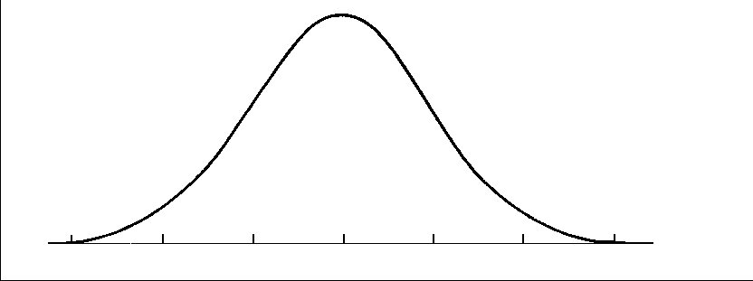

|  |
| --- |
| **Solution** |
| As shown on diagram |
| **Specific behaviours** |
| ✓ or X |

1. Using the normal distribution curve below, illustrate the meaning of

 (2)

μ

μ+σ



|  |
| --- |
| **Solution** |
| As shown on diagram |
| **Specific behaviours** |
| ✓μ+σ  ✓ shaded region |

1. The following linear equations for the mean  and the standard deviation  were determined for the distribution of the weights of individual Yoghurt Muesli Bars:



Use the equations to find the mean weight and standard deviation of Yoghurt Muesli Bars. (2)

|  |
| --- |
| **Solution** |
| 1. – (2) results in   , |
| **Specific behaviours** |
| ✓ solves the two equations simultaneously  ✓✓ correct values for  and |

**Question 6 (continued)**

(b) The graph of *y=f(x)* has been plotted below



On the next 3 pairs of axes A, B, C are graphs of *y=f(-x), f(x-1), -f(x)* in some order. Say which corresponds to which graph. (3)

A B





C



|  |  |
| --- | --- |
| Function | Graph |
| *y = f(-x)* | B |
| *y = f(x -1 )* | C |
| *y = -f(x)* | A |

|  |
| --- |
| **Solution** |
| As in the table |
| **Specific behaviours** |
| ✓✓✓ I mark for each |